View Products

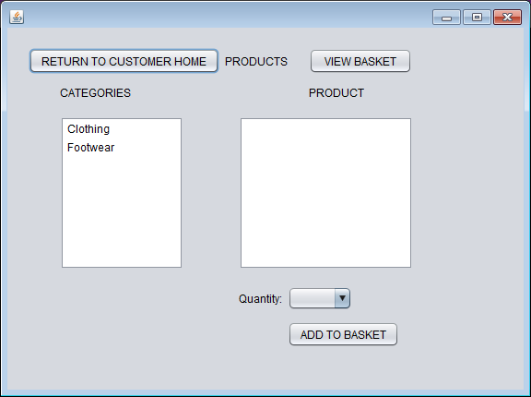

At this stage only the Customers can access this from their Customer Home Page

Customers should be able to Add To OrderLines and Add to Orders Database tables.

At this stage the products quantity will NOT decrement when a product is bought- however you should only allow customers to add a valid quantity to the Basket otherwise an error message is shown… e.g. if there is 5 products available the customers should NOT be able to select 6.

VIEW BASKET should not link anywhere at this time